Dataset for the reference map is flexible for choosing, since the WMM declination is incorporated into the pipeline, any area in Denmark, Europe or in the world can be chosen for flight. Bing satellite images or any other images can be used to the liking. My solution is using Bing because of the MSFS2020 photogrammetry imagery in the simulator is based on Bing imagery. But the main thing is, as long as the extraction of the reference map dataset is as it is shown in the below qgis qmetatiles settings then everything should work seamlessly.
It needs to be kept in mind that MSFS 2020 in CPH sometimes has blurry photogrammetry imagery, unknown reason why. So depending on the internet speed and beefines of the PC you are using the location chosen should be done well. Copenhagen was tested and for this reason it was excluded as the reference map for evaluation and analysis, since it this blurry imagery caused failed estimations.
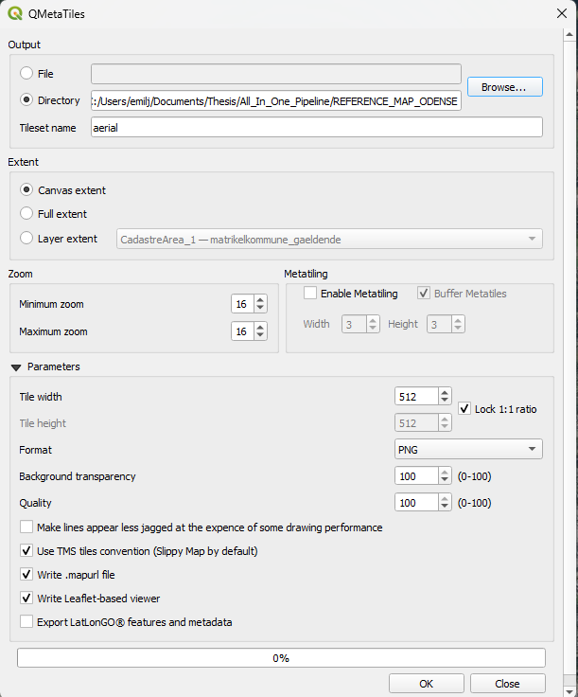
For the evaluation and analysis the location chosen was Odense with the following data the coordinates were extracted with the „QGIS Centroid coordinatte extractor.py“ script:
REFERENCE MAP ODENSE:
- EPSG:25832: 588221.2733690427 6139386.510512081
- EPSG:4326: 55.392805704654506 10.3928236329593
- Magnifier: 100%
- Scale: 1:45000
- Rotation: 0,0

